# Introduction

This paper seeks to cover design methods currently in use in the natural gas distribution industry to classify hazardous areas to prevent accidental ignition of the flammable gases. While design and operational recommendations are presented in this paper, Engineering judgements regarding the specifics of a system to be classified should be made when implementing these solutions on a particular distribution system. This paper was written with a particular focus on the guidelines set forth by API RP 500 and NFPA 497 standards for classifying hazardous areas.

# Definitions and Acronyms

*API RP 500* – The American Petroleum Institute Recommended Practice 500 (Classification of Locations for Electrical Installations at Petroleum Facilities Classified as Class I Division I and Division 2).

*NFPA* – National Fire Protection Association

*NFPA 497* – Recommended Practice for the Classification of Flammable Liquids, Gases, or Vapors and of Hazardous Locations for Electrical Installations in Chemical Process Areas

*Distribution System* – Any system of piping, regulator stations, individual meters and regulators other than a gathering or transmission line.

*NEC* – National Electric Code or NFPA 70.

*Lower Explosive Limit (LEL)* – The lower range of percent gas to air volume ratio that must be present for that gas to be explosive. It’s also used interchangeably with LFL (Lower Flammable Limit)

*Upper Explosive Limit (UEL)* – The upper range of percent gas to air volume ratio that must be present for that gas to be explosive. It’s also used interchangeably with UFL (Upper Flammable Limit)

# Fundamentals

For several reasons, systems leak over time or fail during operation. Design standards were developed from these failures to help prevent accidental ignition of combustible gases and liquids. Accidental ignition occurs from a mixture of three things: flammable substance, ignition source, and oxygen. If the right mixture occurs, an explosion will likely occur. Natural gas (methane or CH4) has a small range for its lower/upper explosive limits (4.4% Volume of gas to air and 16.4% Volume of gas to air). If the concentration of combustible gas to air is outside the explosive range, the gas will not ignite.

Some common flammable sources in natural gas distribution systems are: flanged/compression fittings for pipes, indirect heater process flange connections, control valve vents, pneumatic actuator vents, pig launcher/receiver access hatches, separator/storage tank vents or hatches, etc.

Some common ignition sources are taking pictures with cell phones/cameras, idling vehicles, smoking, welding/grinding, generators for project work, accidental electrical arc, drone usage, etc.

# Ratings

Most of the companies in the United States follow the “Class System”. International companies typically follow the “Zone System”. It’s important to understand these ratings, so products can be sourced that comply with the area the product is being installed in. Below, is a brief description for each rating that may be seen on a product.

*Class 1 Division 1 (C1D1)* – explosive atmospheres that exists normally (process vent, storage vessel, etc).

*Class 1 Division 2 (C1D2)* – explosive atmospheres only exist during abnormal conditions (equipment failure, leaks, etc)

*Group A* – explosive atmospheres typically consist of Acetylene

*Group B* – explosive atmospheres typically consist of Hydrogen

*Group C* – explosive atmospheres typically consist of Ethylene

*Group D* – explosive atmospheres typically consist of Hydrocarbons

*Zone 0 (Equivalent of C1D1 Area)* – explosive atmospheres exists more than 1000 hours per year during normal operation

*Zone 1 (Equivalent of C1D2 Area)* – explosive atmospheres exists between 10-1000 hours per year during normal operation

*Zone 2* – explosive atmospheres exists between 0-10 hours per year (abnormal operation)

The best practice is to procure parts/equipment that has the appropriate ratings for the standards adopted by the company it’s being installed at. There are instances where the supplier is the only vendor that offers the product & it has different ratings. An example of this is a carbon filter for an odorant building. One of the filters/vent companies offers products only with the Zone ratings. It is acceptable to use this product in a C1D1 area, if the product is rated for Zone 0. Similarly, if the product is being installed in a C1D2 area, the product must be rated for Zone 1. It is not recommended to install a product rated for Zone 2 in a C1D2 area without further design mitigation techniques that’ll be discussed later.

# Typical Design Process

Each project should be evaluated for hazardous areas, prior to doing any work. These are some typical steps that are taken to arrive at an appropriate area classification

1. Retrieve the site information
   1. Process piping & connected equipment
   2. Operating conditions
   3. Low-lying areas (pits, vaults, berms, spill containment)
   4. Buildings encompassing flammable substances & any penetrations. Note if there’s any mechanical or natural ventilation
   5. Gas composition for process piping
   6. Adjacent property information (are there any ignition points or flammable sources near the facility)
   7. Any safety devices (gas detectors, flame detectors, etc)
2. Determine flammable substances in the area & list the LEL/UEL limits
   1. Record all chemicals, process gases/liquids found at the site
   2. Organize into classes
      1. Class I = gas
      2. Class II/III = liquid
   3. Use NEC 500 or NFPA 497 & organize the classified substances into their appropriate groups
3. Document when the flammable substance is present
   1. Is the substance present during normal operations
      1. Relief valve relieving pressure
      2. Thief hatch to enter a storage tank
      3. Odorant tank inside a building & is routinely filled
      4. Instrument or process vents venting flammable gas
   2. Is the substance present during abnormal conditions
      1. Pipe leak
      2. Pig launch/receive
      3. Blowdown to isolate pipe segment for work
4. Review the applicable standards and use them to determine the hazardous boundaries for each source point
5. Show these classified boundaries on the design drawings (site plan, elevation views, etc)
6. Repeat process each time the site is modified

An example of this process is shown below for an automated safety valve that’s used to isolate pipe segment during a line rupture/leak.

1. Retrieve the site information
   1. Above grade pipe for bypass valve assembly
   2. Pneumatic double-acting valve on the feederline
   3. Volume bottle to provide actuation gas for the valve, in the event a line rupture occurs
   4. Tubing connections for actuator, volume bottle, transmitters, etc
2. Determine flammable substances in the area & list the LEL/UEL limits
   1. Methane / CH4 is the only flammable substance. LEL = 4.4% and UEL = 16.4%
   2. Possible leak points
      1. Pipe flanges
      2. Compression fittings on tubing
      3. Relief valve on volume bottle + actuator regulator
      4. Process vents on actuator open/close solenoids
3. Document when the flammable substance is present
   1. Vents / Relief valves – always present
   2. Flanges/Compression Fittings – only present during abnormal conditions
4. Review the applicable standards & use them to determine the hazardous boundaries for each source point
   1. API RP 500 since it’s a gaseous substance
      1. 15’ C1D2 - flanges & compression fittings
      2. 5’ C1D1 – relief valve
      3. 1.5’ C1D1 – process vent under 125 PSIG
      4. C1D2 – 15’ boundary extended beyond C1D1 areas
5. Show these classified boundaries on the design drawings (site plan, elevation views, etc)
6. Repeat process each time the site is modified

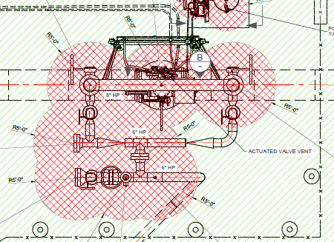

Figure 1: Example Area Classification (Site Plan)

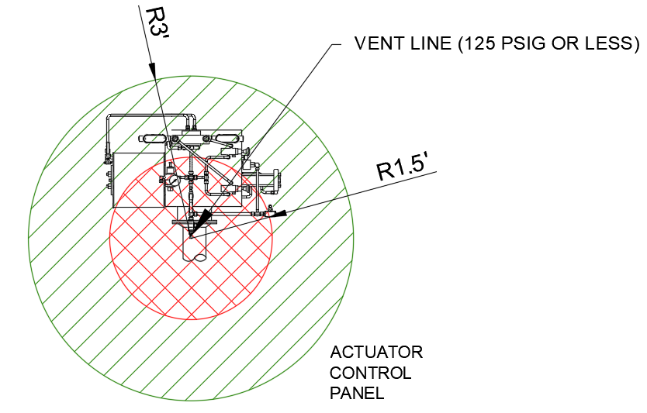

Figure 2: Example Area Classification (Elevation View)

# Design Options

After the area has been evaluated for hazards, the hazards need to be handled properly. There are multiple options for doing this, but only the most common are listed in this report. Refer to API RP 500 or NFPA 497 for more information, if anomalies have resulted from the evaluation. Some of the common mitigation options available are ventilation + gas detection, intrinsically safe circuitry, explosionproof equipment, and pressurized systems.

Once the area has been designed/classified properly, the equipment should be procured so it is rated for the area (C1D1 group D, etc). All electrical circuitry should be installed as stated in NEC articles 500.

# Adequate Ventilation + Gas Detection

The first mitigation is to reduce the classification so it’s a safer area to work. This is done with a combination of adequate ventilation + gas detectors to detect when the atmosphere reaches 40% LFL. The area can be reduced if there are at least 6 air changes per hour with mechanical ventilation or 12 air changes per hour with natural ventilation and has rated gas detection that can detect when the atmosphere reaches 20%-40% LFL. A C1D1 area can be reduced to C1D2 through this technique and a C1D2 area can be reduced to an unclassified area. Upon mechanical failure, the system should be designed to block/bleed the flammable substance from the area until the ventilation system can be fixed. Since it is hard to measure natural ventilation, it is not recommended to use that guideline for reducing classification. Engineering judgement should be used to compare the pros/cons of implementing this scenario.

# Intrinsically Safe Circuitry

The next mitigation is to limit the energy in/out of the hazardous area, so the equipment within the hazardous area doesn’t have the ability to cause an electrical spark. This type of method is called “Intrinsically Safe” circuits. A barrier is typically installed in line with the circuit that goes into the hazardous area.

The most common devices that use an intrinsically safe barrier are form C contacts, transmitters, level switches, pressure switches, etc. It’s often too expensive for the manufacturer to get the “explosionproof” ratings, so they require the end user to install a current-limiting barrier that limits the energy through their device. The energy is limited by a fuse on the “safe” side of the barrier and a Zener diode to ground & the “hazardous” side of the barrier has a current limiting resistor attached. The combination of the diode + resistor makes so the energy to the load doesn’t exceed the threshold where an electrical arc/spark could occur.

NEC dictates how to install intrinsically safe circuitry and requires non-IS circuits to remain isolated from IS circuits at all times. Failure to maintain isolation, will result in the non-IS circuits shorting out the current-limited side of the IS circuit. Since the non-IS circuit doesn’t have any limitations on its source, it’ll provide whatever current is drawn from the fault impedance (typically significantly larger than the current needed to cause a spark). This is why it takes extra consideration to design an IS system properly.

The most common design is to install a separate junction box for the IS circuits and install dedicated conduits for IS circuits. This method guarantees that the IS circuits are never in the same raceway/Panduit as non-IS circuitry.

# Explosionproof Equipment

The next mitigation is to contain the explosion within an enclosure, so the process isn’t effected. The design approach to this technique is that if gas gets into the enclosure & an arc happens within, none of the explosion will escape. There are often a lot of bolts that hold the enclosure shut indefinitely since they’re designed to withstand an explosive force. All conduit penetrations are threaded & conduit seals are installed within 18 inches. This allows for any heat to dissipate within the threads.

# Potential Pitfalls

Each design consideration has pros/cons and engineering judgment should be used to select the equipment that aligns best with the company’s best practices, procedures, and preferences. Some potential pitfalls are listed below.

Reduction of area classification can result in downtime since equipment typically has to be de-energized if equipment failures occur. This should be compared with the cost-savings from reducing the area classification VS how much production is lost while the system is shut down for equipment repairs. Sometimes it makes more sense to keep the areas classified as is, and purchase equipment that is rated for the original areas.

Pressurized enclosures can be an inexpensive solution for equipment that’s not rated for the area, but it can also be detrimental if the system experiences a failure. If the instrument air system fails that’s providing positive pressure into the enclosure, the code mandates that the process has to be shut down until the equipment is fixed.

Intrinsically safe circuitry is the go to fix for a lot of manufacturers since it’s most of the financial responsibility falls on the end user. Up front, the equipment will be significantly cheaper than explosionproof equipment, but there are additional things that should be considered before going the IS route. Installing IS circuitry can be expensive for the end-user since it requires additional enclosures, barriers, and conduit/wire must be provided in order for the manufacturer’s ratings to be valid.

Explosionproof equipment also has limitations. This equipment is only good when all the bolts are secured properly. If an operator has to open the panel while the process is operating, the process must be shut down & the hazards removed before any of the electrical equipment can be worked on. This methodology doesn’t require safety interlocks / shutdowns for equipment failure, so it’s often the preferred choice if the budget allows for it. The other downside of explosionproof equipment is it has terrible ventilation within the enclosure. If there are any heat-generating devices within it, make sure they’re rated to high temperatures or they’ll likely fail over time.

# Management of Change / Drawing Review

While most methods previously described offer protection when a facility is first constructed. It is also important to consider methods for handling changes down the road. Designs on distribution and transmission facilities should follow a Management of Change (MOC) process where key stakeholders with subject matter expertise (both through education and experience) review designs for any changes to the hazardous area plan. Compliance with an MOC process will identify changes that need to be mitigated and communicate where new hazards may exist.

# Conclusion

Equipment should be rated for the area it is installed in. There are multiple ways the API RP 500 and NFPA 497 standard can be interpreted, but it is the designer’s job to evaluate what level of risk the company deems acceptable and implement a solution that minimizes the risk. The industry standards provide the minimum guidelines to protect a particular system. If the designer feels that the guideline is lacking in a certain area, it is appropriate to error on the side of caution and design conservatively: larger boundary for hazardous area, limiting the energy level so ignition does not occur level, making the area a more stringent classification, etc. With all conditions considered, if something feels unsafe, a more stringent mitigation technique should be installed so operators go home safe to their families at the end of the day.

Finally, it is imperative that the facility is monitored throughout its lifecycle, and the area classification plan is evaluated every time there’s a change at the facility. It’s best practice to handle this through a MOC process or drawing review, so the appropriate stakeholders update the plan as needed and make sure all new equipment is rated appropriately for the area it’s being installed in.